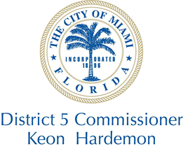
Protocol Request Form
Please note the following:
All requests must be supported by sufficient background information. Please include a copy of event invitation and or request.
Please submit request at least 30 days in advance.
Memorial tributes will not be subjected to this requirement.
Today’s Date: _________________________ Date of Presentation: __________________________
Will item need to be presented? _____________ Event Location: ________________________________
Time of Event: _______________________ Point of Contact: ______________________________
Phone number: __________________________ Name of Honoree: _____________________________
Email: _______________________________________________________________________________
Reason for request: __________________________________________________________________________________________________________________________________________________________________________
Has the honoree been honored but the City of Miami before? If so, please list the name of the office and year the presentation was made? : _______________________________________________________
___________________________________________________________________________________
Signature on Document
Mayor Commissioner Hardemon Entire City Commission

Requests are awarded at the discretion of the Commissioner

